UNITED STATES
SECURITIES AND EXCHANGE COMMISSION
Washington, D.C. 20549

SCHEDULE 14A
Proxy Statement Pursuant to Section 14(a) of the
Securities Exchange Act of 1934
(Amendment No.)

Filed by the Registrant ☒
Filed by a Party other than the Registrant ☐
Check the appropriate box:

☐ | Preliminary Proxy Statement

☐ | Confidential, for Use of the Commission Only (as permitted by Rule 14a-6(e)(2))

☐ | Definitive Proxy Statement

☒ | Definitive Additional Materials

☐ | Soliciting Material under §240.14a-12
PELOTON INTERACTIVE, INC.
(Name of Registrant as Specified In Its Charter)
(Name of Person(s) Filing Proxy Statement, if other than the Registrant)
Payment of Filing Fee (Check all boxes that apply):

☒ | No fee required

☐ | Fee paid previously with preliminary materials

☐ | Fee computed on table in exhibit required by Item 25(b) per Exchange Act Rules 14a-6(i)(1) and 0-11


Your Vote Counts! *Please check the meeting materials for any special requirements for meeting attendance. Smartphone users Point your camera here and vote without entering a control number For complete information and to vote, visit www.ProxyVote.com Control # T04852-P59163 PELOTON INTERACTIVE, INC. 2026 Annual Meeting Vote by December 7, 2026 11:59 PM ET PELOTON INTERACTIVE, INC. 441 NINTH AVENUE, SIXTH FLOOR NEW YORK, NEW YORK 10001 You invested in PELOTON INTERACTIVE, INC. and it’s time to vote! You have the right to vote on proposals being presented at the Annual Meeting. This is an important notice regarding the availability of proxy materials for the stockholder meeting to be held on December 8, 2026. Get informed before you vote View the Notice and Proxy Statement and Annual Report online OR you can receive a free paper or email copy of the material(s) by requesting prior to November 24, 2026. If you would like to request a copy of the material(s) for this and/or future stockholder meetings, you may (1) visit www.ProxyVote.com, (2) call 1-800-579-1639 or (3) send an email to sendmaterial@proxyvote.com. If sending an email, please include your control number (indicated below) in the subject line. Unless requested, you will not otherwise receive a paper or email copy. Vote Virtually at the Meeting* December 8, 2026 11:00 a.m., Eastern Time Virtually at: www.virtualshareholdermeeting.com/PTON2026

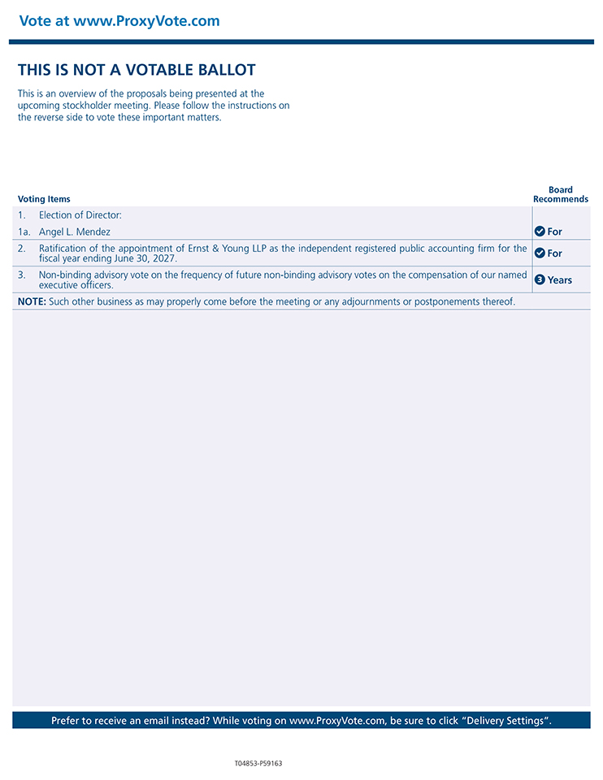
Vote at www.ProxyVote.com Prefer to receive an email instead? While voting on www.ProxyVote.com, be sure to click “Delivery Settings”. Voting Items Board Recommends T04853-P59163 THIS IS NOT A VOTABLE BALLOT This is an overview of the proposals being presented at the upcoming stockholder meeting. Please follow the instructions on the reverse side to vote these important matters. 1. Election of Director: 1a. Angel L. Mendez For 2. Ratification of the appointment of Ernst & Young LLP as the independent registered public accounting firm for the fiscal year ending June 30, 2027. For 3. Non-binding advisory vote on the frequency of future non-binding advisory votes on the compensation of our named executive officers. 3 Years NOTE: Such other business as may properly come before the meeting or any adjournments or postponements thereof. 

